Dr. Bart van Straten, MBA
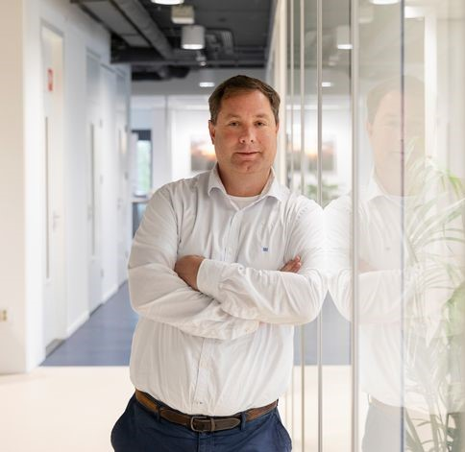
Bart van Straten is an expert in the field of sustainability and the circular healthcare economy. As an author, speaker, entrepreneur and educator, Bart helps ambitious persons and organizations to build (stronger) circular strategies. He is affiliated with several institutions and companies including Van Straten Medical and GreenCycl as well as educational and government-related institutions. He co-founded GreenCycl, an organization with a mission to decrease the amount of medical waste. Bart holds a doctorate in BioMedical Engineering from Delft University of Technology/TU Delft with a specialization in the circular reuse of surgical devices and surgical waste materials. During his PhD research, Bart developed a Field Lab together with Tim Horeman for experimental research on reprocessing surgical waste into new raw materials and medical products. His research has won several awards, for example in the Utrecht Circular Innovation Top 20, as builder of the world’s first recycling process for hospital waste.
Bart joined the research group Sustainable Surgery & Translational Technology at TU Delft, where he is a lecturer on medical device prototyping and teaches several related courses. Bart focuses on integrating sustainable engineering and circular design in education as a researcher and lecturer. He has published widely on using the operating room as gold mine for new raw materials. As co-author and chairman of the Dutch NEN Platform Sustainability & Medical Devices, he was involved in writing the Dutch national NEN-3 guideline for reusing single-use medical devices which was published by NEN on 1 June 2020.
Bart spent his career creating expertise and insights on how to create circular strategies in companies, hospitals and other organizations. He is the author of ‘Creating Circular Healthcare Strategies’ and contributor to many sustainability initiatives.
Bart has also received various other educations, including an MBA (1994) at the EU Business School and a master's degree in international trade/public administration in Brussels (1996), completed training as an airline pilot (2000) and training as a supervisor. In addition to his work, he is a director and a member of several supervisory boards.

